Independent design research – Luke Baldwin

Research further into our chosen game genre and the mechanics that will be substituted

Most of these mechanics explained can be used/substituted instead of Manual movement

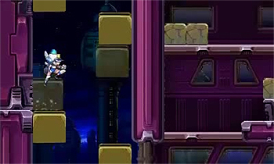Platform games –

Mechanics that can be changed or edited or included in our game to make it different from other game genres:

Switching Platforms – This makes games interesting at platforms can become varied and can include different enemies/obstacles as you progress in the game.

In a top-down game we would have to make platforms move but can be seen from above. Our game will use gravity but can use a platform that can take our character in the correct direction or in the wrong one to cause the player to re think the puzzle and the path they need to slide down to complete the level.

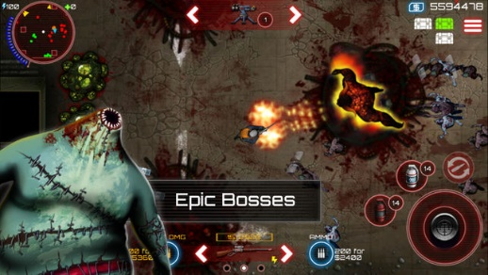Rolling – This type of movement in a platform game can helps a character dodge an enemy that could maybe be high in the air, or to increase the speed in which the character in game can progress through a level for a limited amount of time. This mechanic could be changed by including a power up that makes you able to crouch but lets you run faster than normal. In a top down game rolling could be used to avoid enemies in top down games such as SAS zombie assault.

Long Jumps / Double Jump – In a platform game this mechanic can be used when a character gets a power up or it is used so movement is more fun and strategic this mechanic can be used in a top down game to avoid enemies or to jump over certain objects. In our game we maybe able to jump or hover over certain objects. Are game uses gravity movement so jumping maybe used differently and more quickly or slowly.

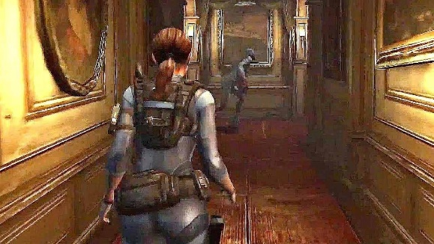Adventure games =

Movement in Adventure games are normally controlled by players using normal movement keys or left, right, up and down keys such as games like Minecraft, fire watch etc. Our game will change this idea as we are using gravity that will move us along.

Adventures games normally let you control one character at a time so including 2 could add a mechanic to the game we could use this mechanic in our games as they player would have to get two characters through the level at the same time or one after the other.

Adventure games are always about discover of the unknown and new concepts so in our game we can used a wide variety of levels and different enemies that players can discover.

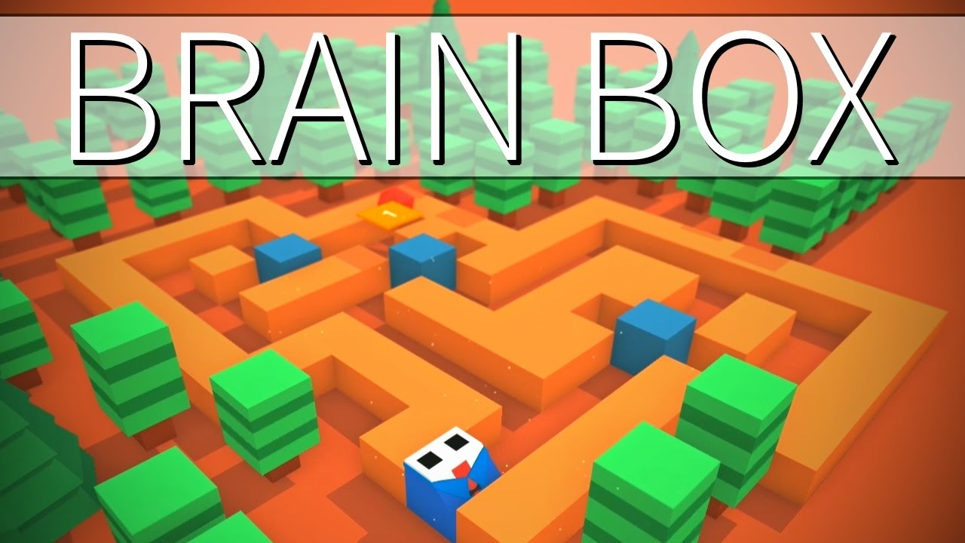Puzzle games = Puzzle games use mechanic that make people use their brains to find ways of completing their levels they normally use minimal assets but are elegant with the assets they use. Many games can be classed as a Puzzle games as most games teach you something and require you to work out challengers.

Puzzle games use different levels to increase level hardness and difficulty to make players constantly working harder and to make sure they come back to the game. With our game we can include harder levels as they progress and harder obstacles to avoid.

Most puzzle games also use ASD keys to move around but with our game we are using gravity and the left, right, up and down keys this will add more difficulty as movement is more difficult and needs to you think about which direction you want to get to so you must be more carful in the key you press before you press it all the time to make sure you don’t end up going in the wrong direction that can cause you to lose time.

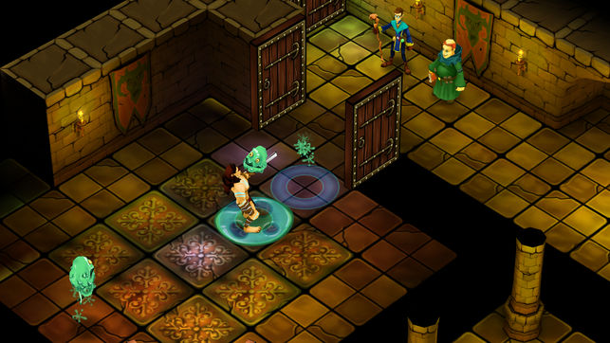Dudgeon crawlers = These games use a mechanic where they pick up items from the world that is called ‘loot’ which include different weapons or power ups. These could be changed to include killing enemies which adds points to a score which enables you to pick an upgrade or item you want depending on the number of points you currently have. Think about the points somewhat of a currency.

Most dungeon crawlers also use manual movement so instead adding sliding and gravity movement could take these games to different difficultly levels and other ideas or strategy. These games normally use a large number of enemies attacking a character over a short period of time but can be changed to only a few numbers of enemies over the entire game but instead using more puzzle based mechanics through more difficult movement where you have to avoid enemies to escape/progress through a level as you will have to align yourself toward to exit of the level so you can slide towards it.

Most games include killing enemies but are game can simply require players to avoid them.